**VNM Motion System and Simtools Guide**

# 1. Download VNM UI

Download [VNM UI](https://vnmsimulation.com/download) and open it (add exception for VNM UI if computer detects virus). Click tab motion:

In Number of actuators: Choose exactly how many actuator in your motion system.

In Pulse Frequency: Choose whatever frequency as your liking. **We recommend you should try from 100-250 at the beginning.** After being familiar with motion system, you can choose higher frequency. The higher pulse frequency the higher speed of actuator.

Smoothing to make the motion system work smoother. The higher value, the higher smoothness.

Number pulse per loop is the number of pulses you want to send to actuator each 1ms. The higher value the faster of actuator’s speed.

Actuator stroke length: choose each actuator to config the length of stroke based on your system.

Other parameters should let it be as default of VNM Motion System.

# 2. Simtools V2

## 2.1. Download simtool v2 and plugin

download [simtools V2](https://simtools.us/downloads-links/)

Download [plugin](https://simtools.us/plugin_library/)

Open simtool plugin updater (in simtool installation folder)

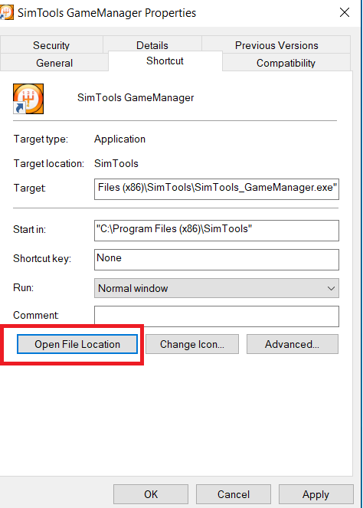

Drag and drop downloaded plugin above to plugin manager (just need to do one time)

## 2.2. Simtool V2 configuration

Open Simtool GameEngine 🡪 Tool 🡪 Axes Presets 🡪 choose file “VNM Motion Platform Simtool V2 Presets” as your motion system, drag and drop to Preset installer

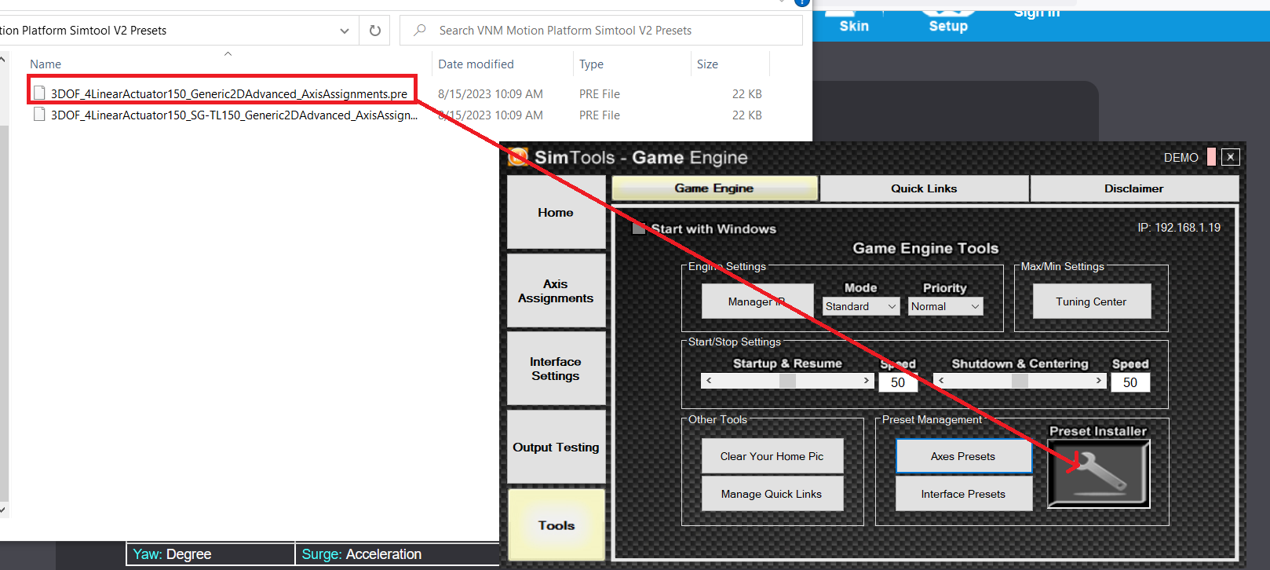

Same with Interface Preset.

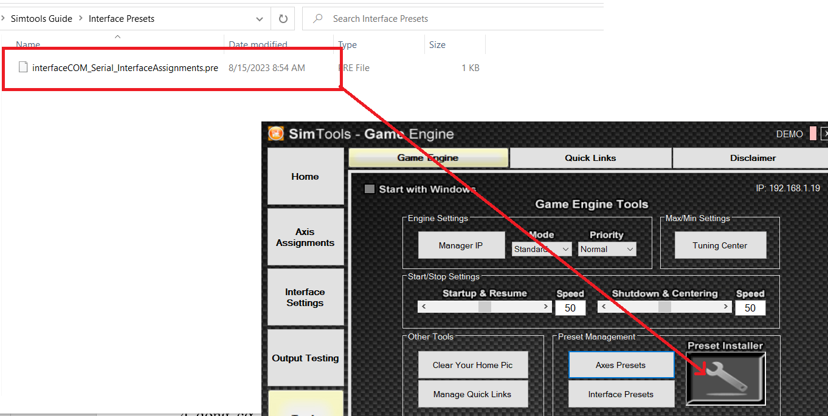

Before connecting the motion controller to PC. The 1st you open Device Manager. Connect Motion controller to PC and you will see new port com appears in Device Manager -> Ports (COM&LPT).

In Simtool Game Engine 🡪 Interface Settings 🡪 Preset choose the interface preset same as file you added above, choose port com of VNM Motion Controller, other configure like picture bellow 🡪 click Save

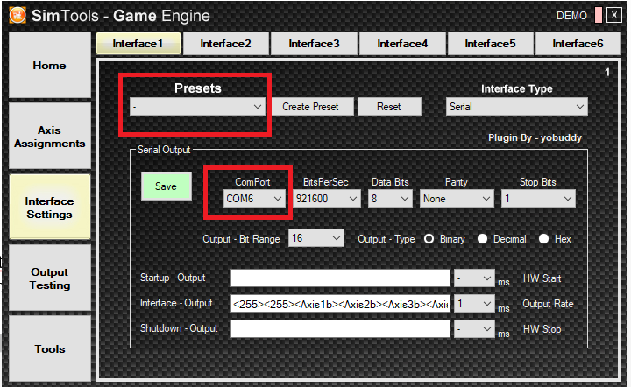

In Simtool Game Engine 🡪 Axis Assignments 🡪 Axis Type -> Choose “Generic 2D Advanced” 🡪 in Preset choose name as file motion you added above.

In Gamelist choose which game you want to play.

## 2.3. Test

In Simtools Game Engine 🡪 Output testing 🡪 Turn on and test each effects.

Turnoff after testing.

## 2.4. Patch Game

Automatically Setup Telemetry for game, just choose the game you want to play 🡪 click patch, choose the game installation folder 🡪 Patch Game (need to do one time)

